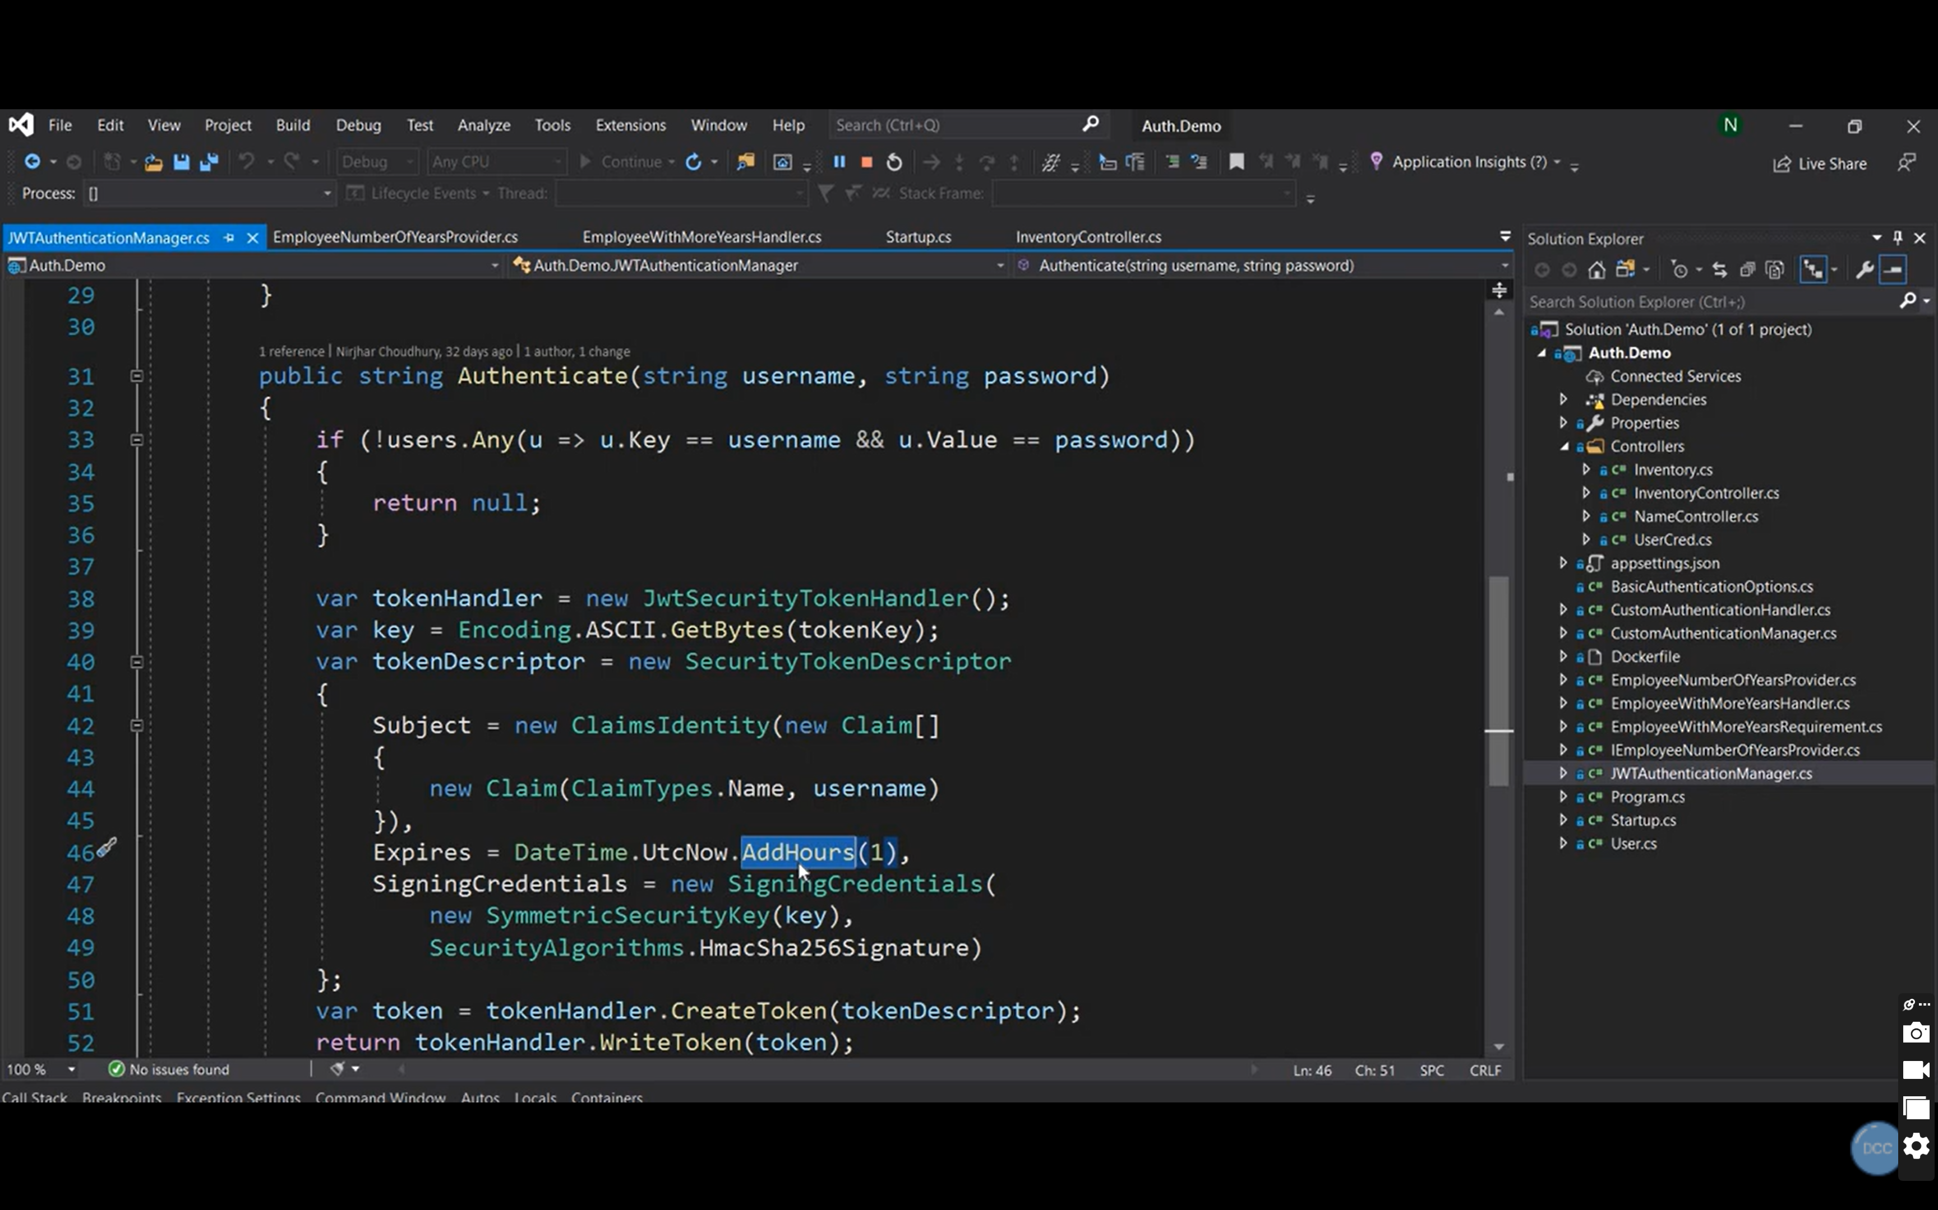

namespace WebApi.IRepo

{

public interface IRefreshTokenGenerator

{

public string GenerateRefreshToken();

}

}

using System.Security.Cryptography;

using WebApi.IRepo;

namespace WebApi.Repository

{

public class RefreshTokenGenerator : IRefreshTokenGenerator

{

public string GenerateRefreshToken()

{

var randomNumber = new byte[32];

using(var randomNumberGenerator = RandomNumberGenerator.Create())

{

randomNumberGenerator.GetBytes(randomNumber);

return Convert.ToBase64String(randomNumber);

}

}

}

}

namespace WebApi.Models

{

public class AuthentcationResponse

{

public string JwtToken { get; set; }

public string RefreshToken { get; set; }

}

}

public class AuthenticateManager1 : WebApi.IRepo.IAuthenticationManager1

{

StudentDbContext _context;

IConfiguration _config;

IRefreshTokenGenerator _refreshTokenGenerator;

public AuthenticateManager1(StudentDbContext context, IConfiguration config,

IRefreshTokenGenerator refreshTokenGenerator)

{

_context = context;

_config = config;

_refreshTokenGenerator = refreshTokenGenerator;

}

string token = GenerateToken(email, password);

string refreshToken = _refreshTokenGenerator.GenerateRefreshToken();

return new AuthentcationResponse

{

JwtToken= token,

RefreshToken= refreshToken

};